# REPORT FOR RESTAURANT PROJECT 1

As a project work for Course

HTML AND CSS PROGRAMMING(CSE326)

Name : UPPADA SATWIK

Registration Number : 12111298

Name : MALLU PARDHIVA

Registration Number : 121O7835 Program : CSE B. Tech

School : School of Computer Science & Engineering

Name of the University: Lovely Professional

University Date of submission : 20th April 2022



2



20th APRIL 2022

# ABSTRACT: -

The Restaurant project is a webpage (software application) which avoids hours of time to check about the Restaurant (I named the Restaurant as “TASTY”). The webpage consists About the Tasty Restaurant and Menu-items in the Restaurant and some pictures of the Restaurant in Gallery and mainly Address and Contact details of the Tasty Restaurant. The Restaurant website gives the whole information about TASTY RESTAURANT. It uses for growth of Restaurant business and its also helps to contact the Restaurant through Contact us form.

# ACKNOWLEDGEMENT: -

I would like to thank my mentor – MD Imran Hussain for his advice and inputs on this project. Many thanks to my friends and parents as well, who spent countless hours to listen and provide feedbacks.

3



## ABSTRACT 02

1. INTRODUCTION 04
   1. CONTENT
   2. MOTIVATION
   3. IDEA

## TEAM MEMBERS WITH ROLES 05

* 1. MEMBERS
  2. CONTRIBUTIONS

## SCREENSHOTS 06

1. CODE 10
2. ABOUT RESTAURANT WEBSITE 18
3. CONCLUSION 18

4

# INTRODUCTION: -

1. CONTENT



This project has been done as part of my course for the CSE at Lovely Professional University. Supervised by Imaran Hussian Sir.

1. MOTIVATION



Being extremely interested in everything having a relation with the WEB DEVELOPMMENT, the group project was a great occasion to give us the time to learn more and confirm our interest for this field. As per my research Restaurant project is a basement project for web developers so I choose this one as my project. It is the basic layout for all Restaurant websites.

1. IDEA



As a first experience, we wanted to make our project as much as admirable. By approaching every different Steps of the HTML and CSS programming process and trying to understand deeply. I just wrote the html code for the format of given project by my own knowledge. By seeing the templates of Restaurant websites, I got an idea how to present it in html with that backgrounds and links.

5

TEAM MEMBERS: -

: -



Contributions: -

* 1. Coding(joined)
  2. Report



Contributions: -

* + 1. Coding(joined)
    2. Pictures collection

SCREENSHOTS: - 6

### MAIN PAGE: -

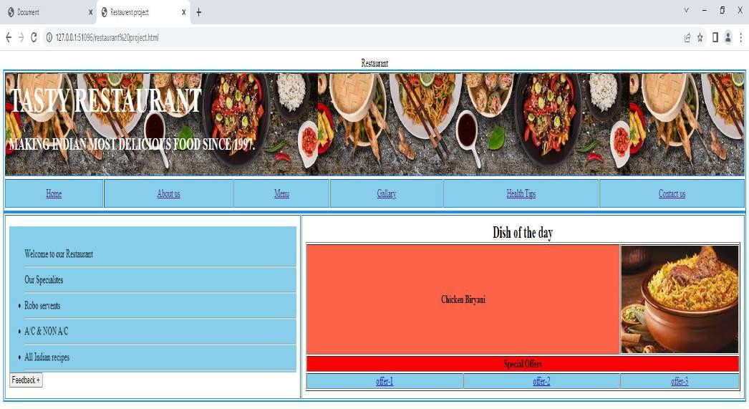

HOME PAGE: -

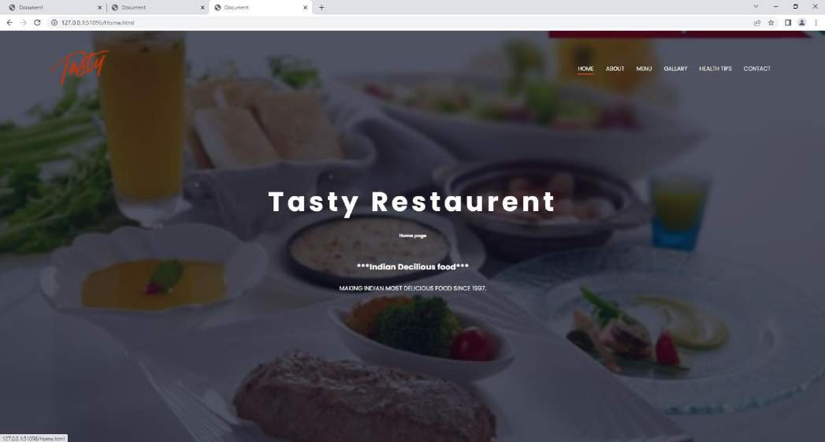

7

ABOUT PAGE: -

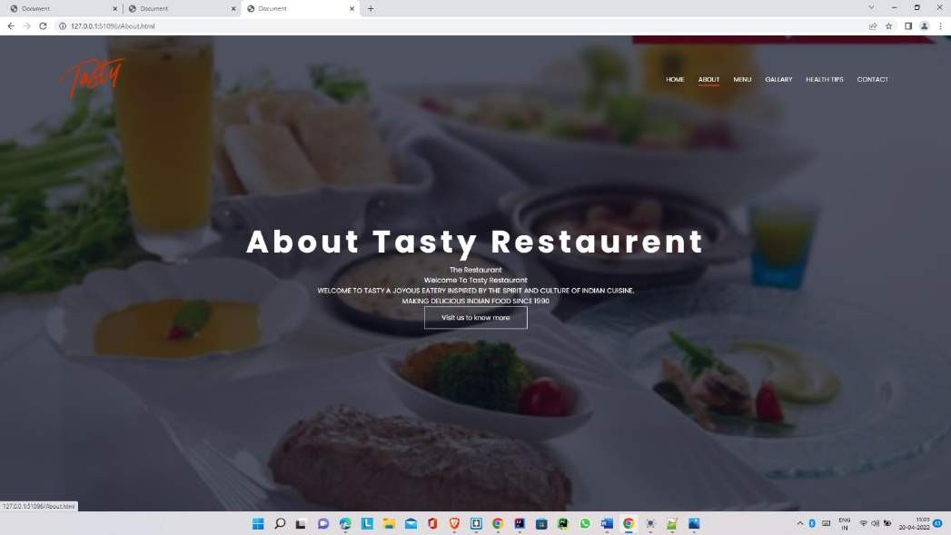

MENU PAGE: -

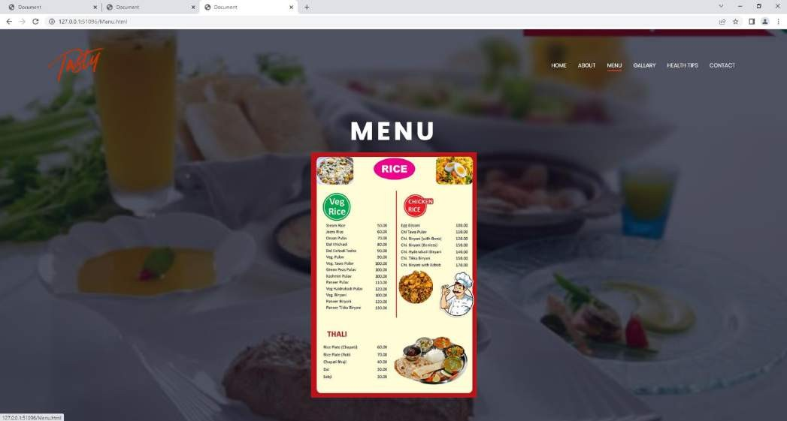

GALLERY PAGE: - 8

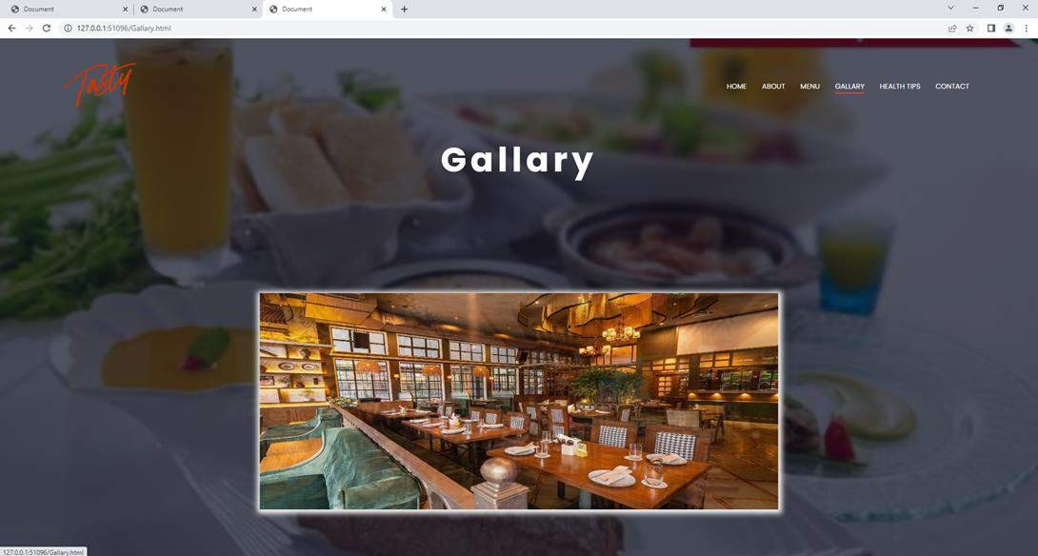

HEALTH TIPS PAGE: -

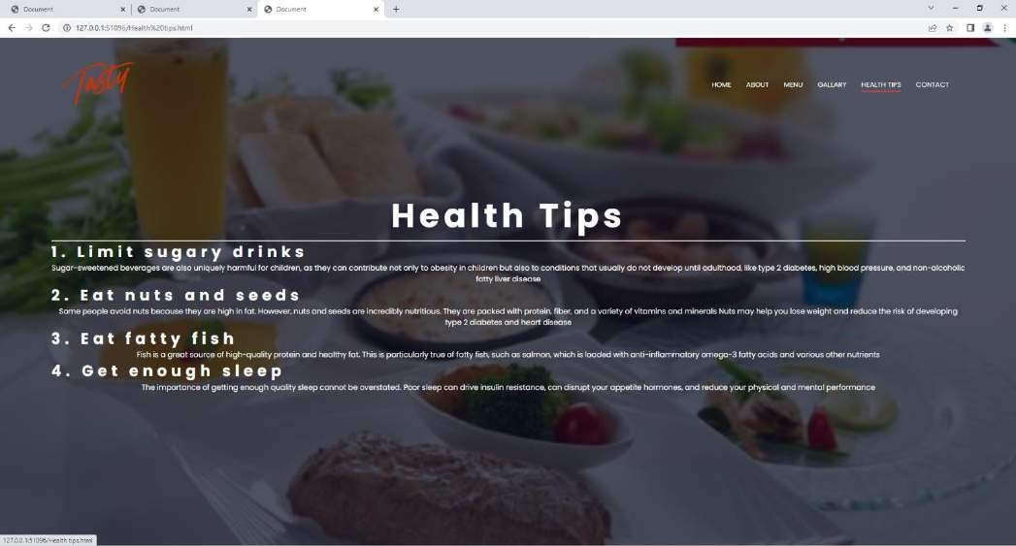

CONTACT PAGE: - 9

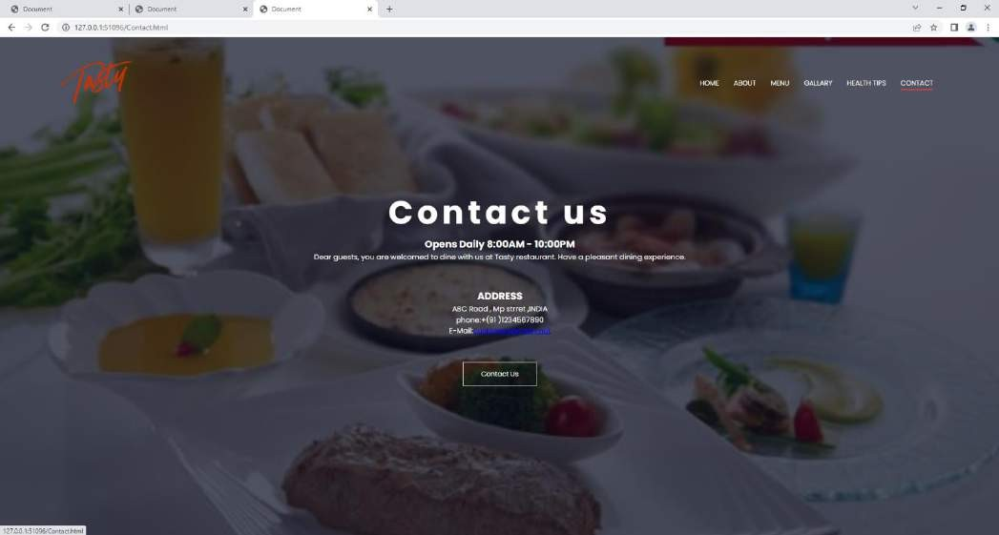

FEEDBACK PAGE: -

Before:

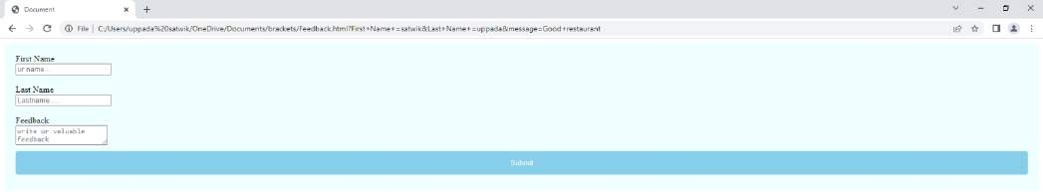

After: -

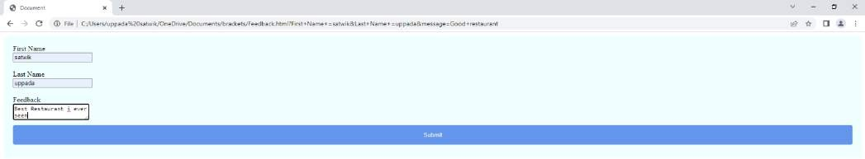

CODE: - 10

MAIN PAGE CODE: -

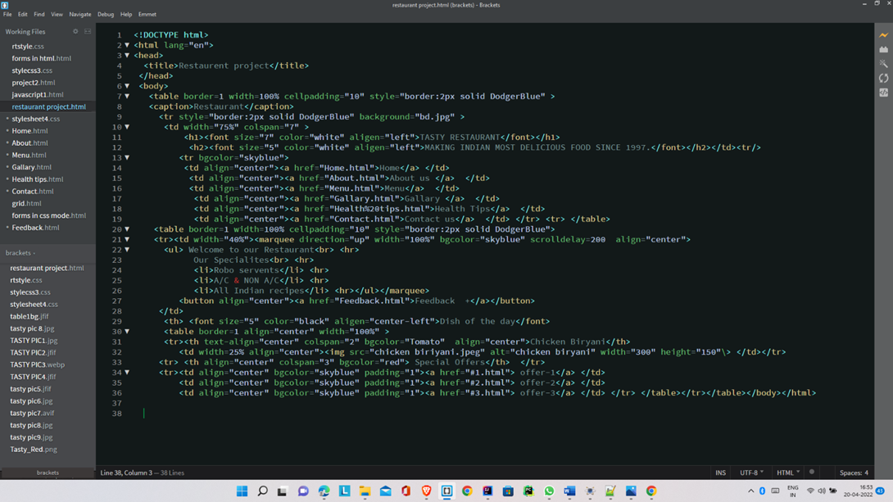

STYLESHEET CODE: -

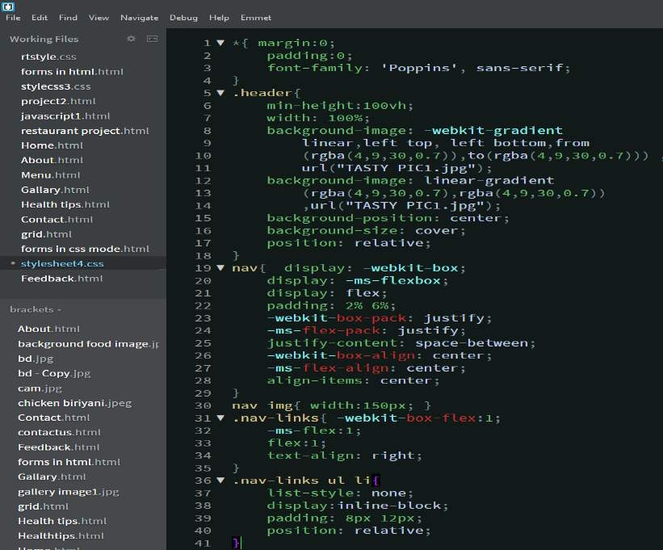

11

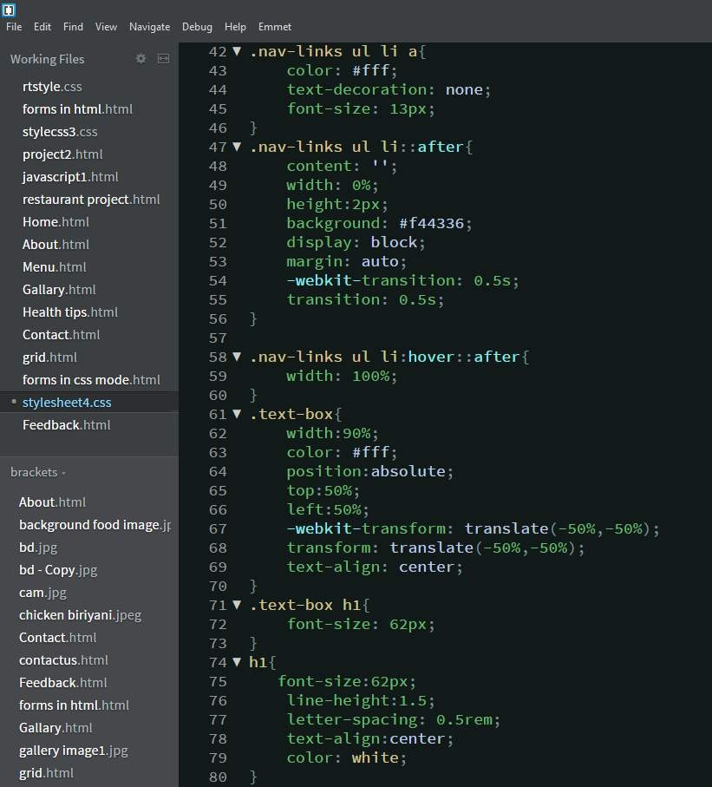

12

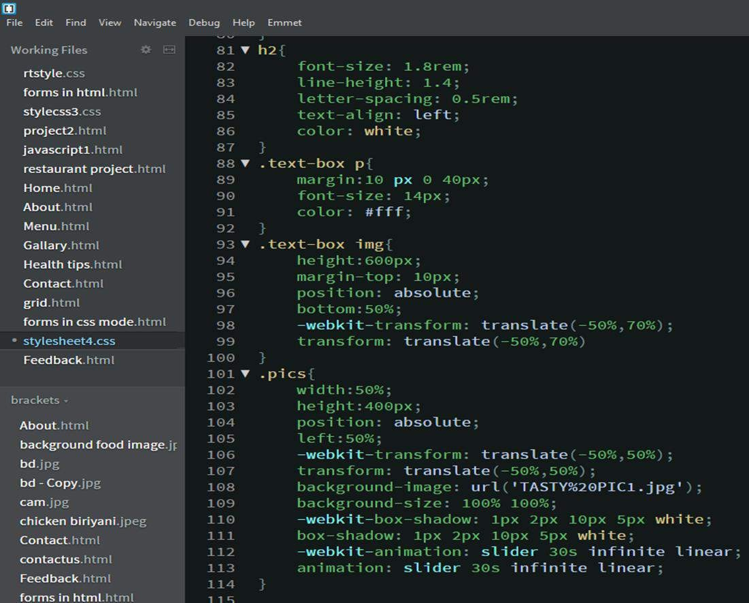

13

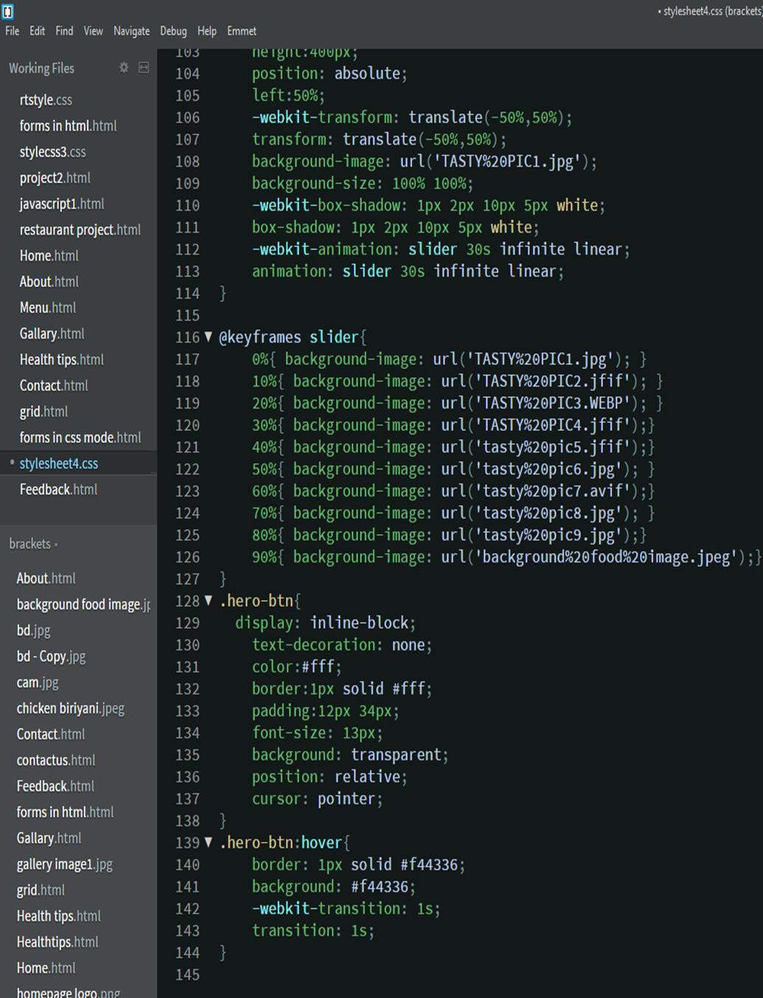

14

## HOME PAGE CODE: -

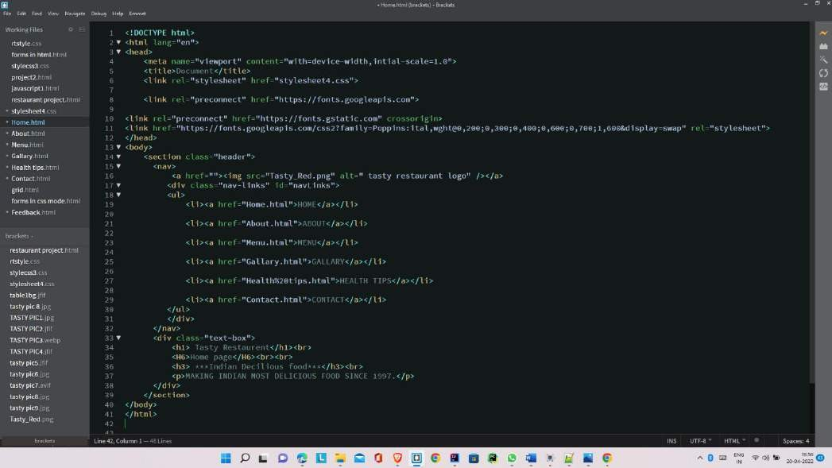

ABOUT PAGE CODE: -

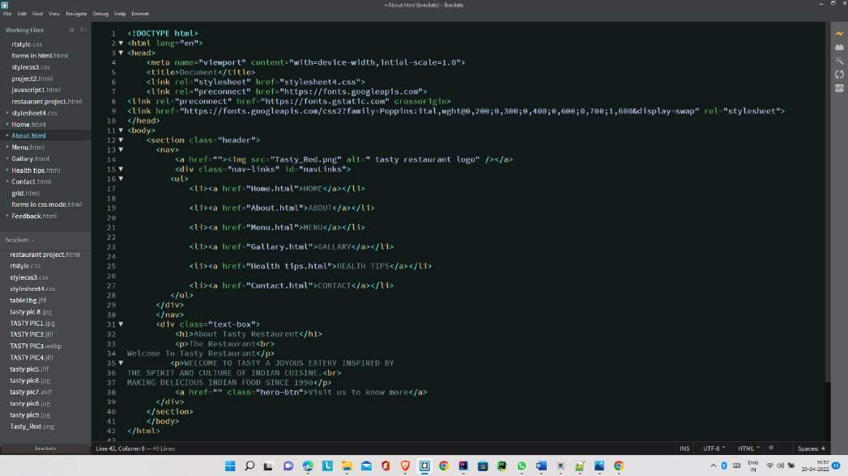

15

## MENU PAGE CODE: -

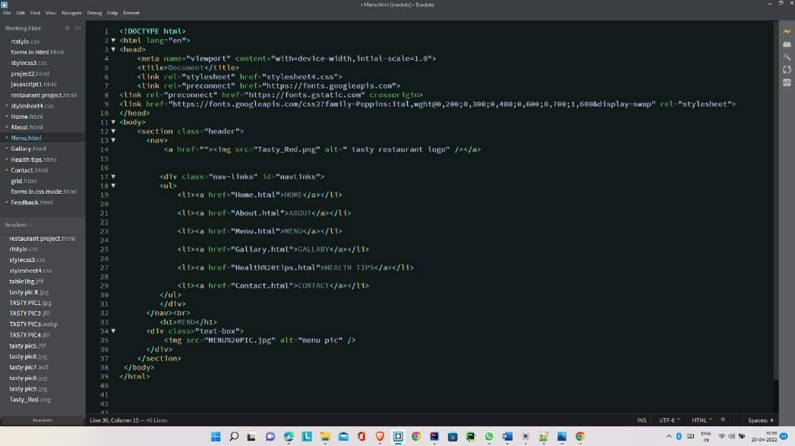

GALLERY PAGE CODE: -

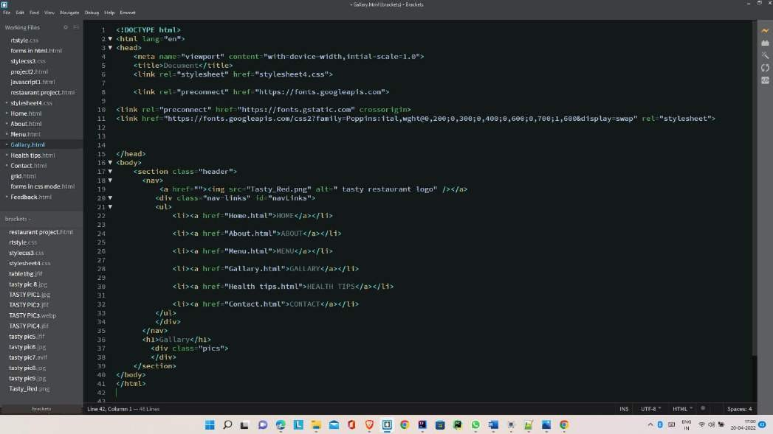

HEALTH TIPS PAGE CODE: - 16

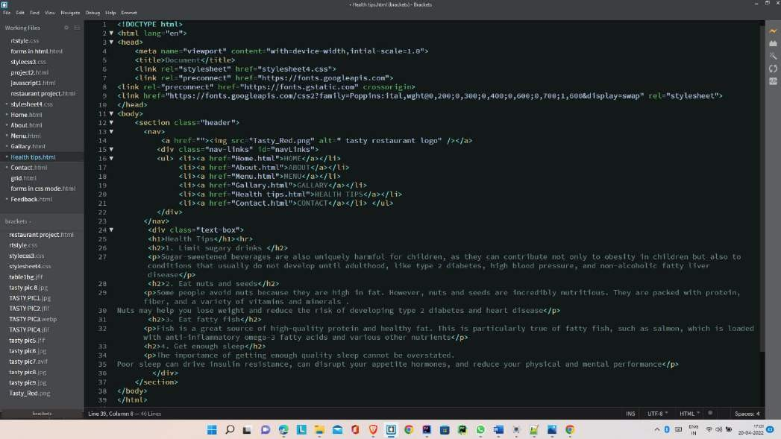

CONTACT PAGE CODE: -

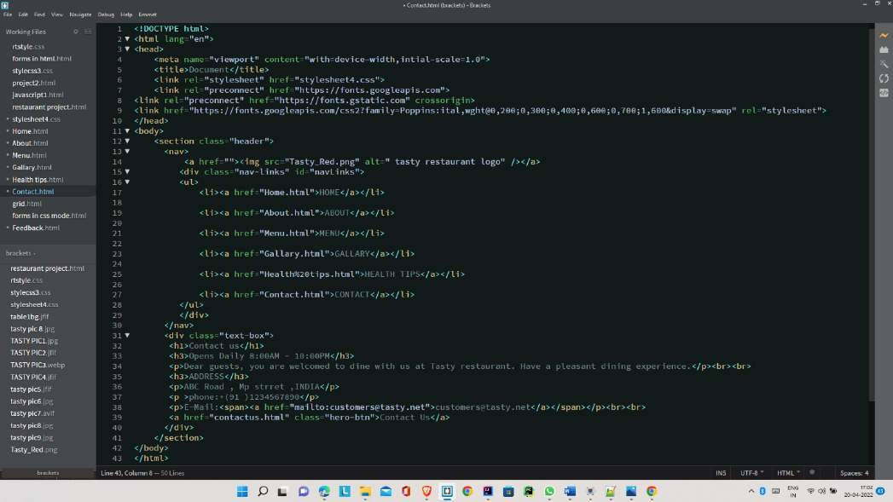

FEEDBACK PAGE CODE: - 17

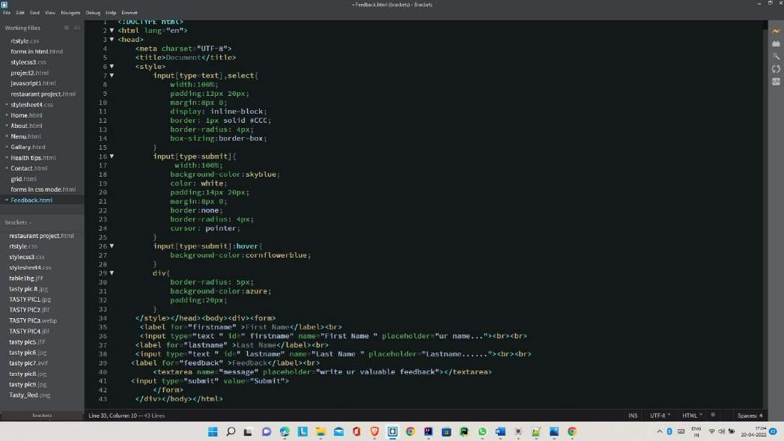

 18

**ABOUT: -**

Restaurant website is an online website which useful for the customers to know about the Restaurant (TASTY). It is a basic design for all online Restaurant websites. It consists of home page, about page, Menu page, Gallery which is useful to know the neatness and infrastructure of the Restaurant. It also contains useful health tips and contact details. The Restaurant websites will help in growth of the business. And it also helpful for Restaurant faculties and owner. Because, it has a feedback section so they will know customers feedback .so that it helps to improve the customers wishes how they comfortable at that Restaurant

**CONCLUSION: -**

It is our team’s hope that this document will be of huge help with understanding of our little project as we have used a different approach which has proved beneficial for us and easy for us to understand the vast ocean that is WED DEVELPOMENT. We have reached the maximum accuracy of 95% after data cleaning but we will work forward to increase this accuracy little by little.

PICTURES USED FOR WEBSITE CONSTRUCTION



TASTY PIC4.jfif

### Tasty_Red.png



TASTY PIC1.jpg

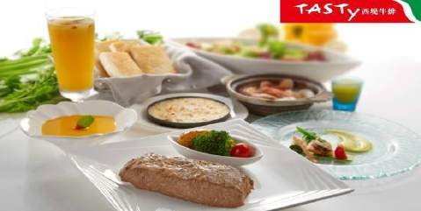

tasty pic9.jpg tasty pic8.jpg

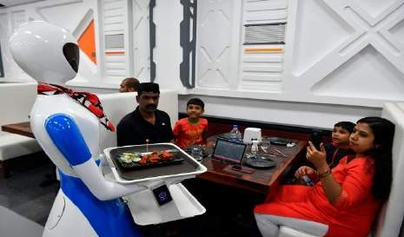

tasty pic6.jpg tasty pic5.jpg

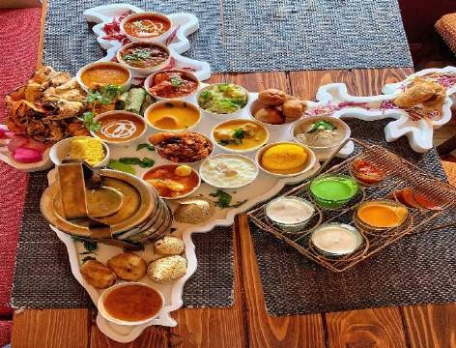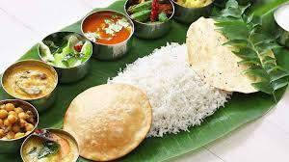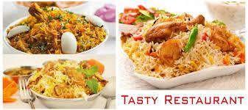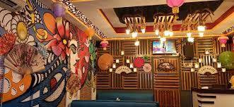

TASTY PIC2.jfif

19

MENU PIC.jpg chicken biriyani.jpeg

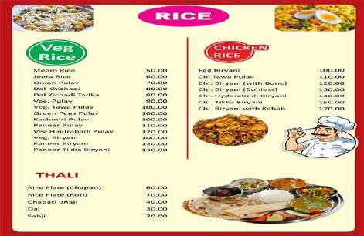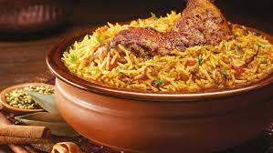

Bd.jpg

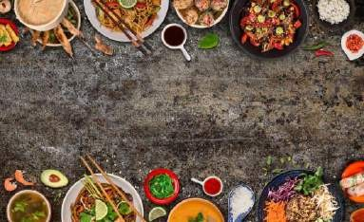

Fonts used in html code

<link rel="preconnect" href="https://fonts.googleapis.com">

<link rel="preconnect" href="https://fonts.gstatic.com" crossorigin>

<link href="[https://fonts.googleapis.com/css2?family=Poppins:ital,wght@0,200;0,](https://fonts.googleapis.com/css2?family=Poppins%3Aital%2Cwght%400%2C200%3B0) 300;0,400;0,600;0,700;1,600&display=swap" rel="stylesheet">

20